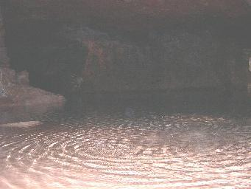
An underground rock pool – one of the most beautiful sights at Clearwell. Across this pool Johnathan, one of the owners, floated across Merlin for me to inspect at close quarters. It had been kept in a store cupboard for nearly three decades !
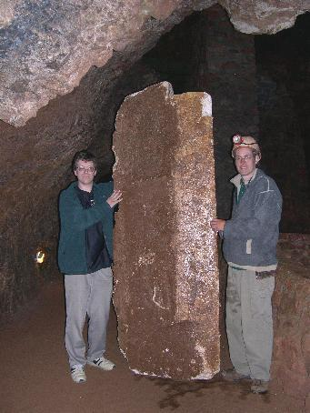
The remaining piece of Merlin, painted the colour of rock and held by myself (on the left) and Johnathan Wright – son of the original owner, who remembers well the filming. Even in this photograph you can see the large lighter section (towards Johnathan) where the piece looks like it interlocked with at least one more section.

